Project Development Phase
Model Performance Test

Date | 10 February 2026
Team ID | LTVIP2026TMIDS24884
Project Name | Heart Disease Analysis
Maximum Marks

Model Performance Testing:
Project team shall fill the following information in model performance testing template.
S.No. | Parameter | Screenshot / Values
 | Data Rendered | Patient dataset with 500+ records including Age, Sex, Blood Pressure, Cholesterol, Max Heart Rate, Exercise Induced Angina, etc.  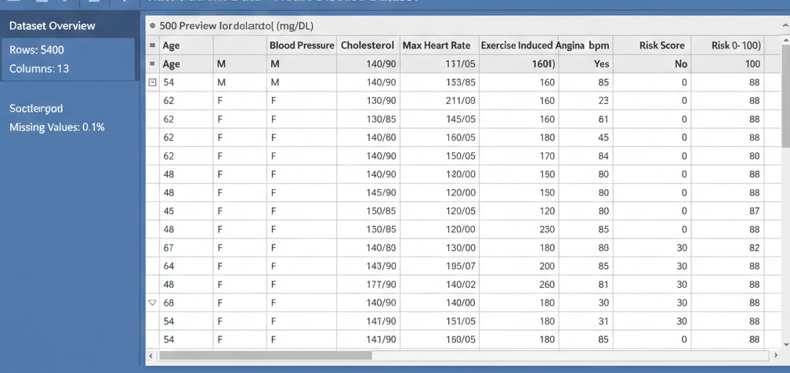
 | Data Preprocessing | Missing values handled, outliers removed, categorical variables encoded (e.g., Sex: M/F), normalization applied for numeric features.
3. | Utilization of Data Filters
  Filters applied for Age range, Gender, Cholesterol level, and Blood Pressure. Users can interactively slice data to view specific risk groups.
4. | DAX Queries Used | Calculated risk score using formula: Risk_Score = 0.3*Age + 0.2*Cholesterol + 0.25*BP + 0.25*Max_Heart_Rate.
5. | Dashboard design | Number of Visualizations / Graphs – 6  Graphs include: Risk Score Distribution, Age vs Risk Scatter Plot, Cholesterol vs Risk, BP vs Risk, Gender-wise Risk Pie Chart, Max Heart Rate Histogram
6 | Report Design | Number of Visualizations / Graphs – 4  Graphs included in report: Risk Score Summary, Top 10 High-Risk Patients Table, Age vs Risk Scatter, Gender-wise Risk Pie Chart

